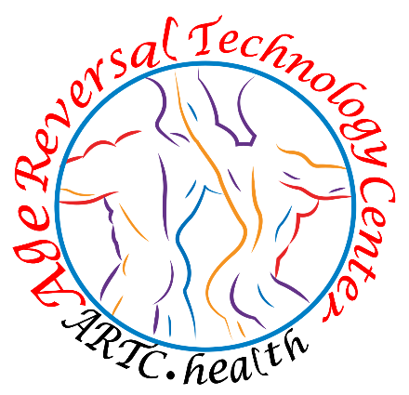
YOUR PATIENT NUMBER IS: ________________________

Congratulations! On your recommendation.

In your email you will receive from The Florida Department of
Health direction to set up a password and finished your application
process. Follow the instructions included in this info package. After you have finished this process, you should receive your Approval/Temporary Card by e mail in 24 hrs. Any questions or problems with your card please contact:
Florida Department of Health
OFFICE OF MEDICAL MARIJUANA
PH 800-808-9580

Liberty Health Muv Dispensary Curaleaf Cannabist Trulieve
941-264-1399 941-312-2699 877-303-0741 941-216-7838 941-216-0165 2067 Siesta Dr 5045 Fruitville Rd 1455 S Tamiami Trail 4549 14th St W 4804 Manatee W Ave
Sarasota FL Sarasota, FL Sarasota, FL Bradenton, FL Bradenton, FL

Trulieve Trulieve VidaCann Trulieve Surterra Wellness
941-444-6845 941-800-2003 941-254-7494 844-878-5438 850-391-5455
935 N Beneva Rd 1100 S Trail 5203 Cortez Rd 6722 14th St W 6815 53rd Av
Sarasota Fl Osprey Fl Bradenton Fl Bradenton, FL Bradenton, Fl

Cannabist Sunnyside GrowHealthy MuV Dispensary
6979 S Trail 8307 N Lockwood Ridge Rd 3555 Clark Rd 4312 75th St W Sarasota Fl Sarasota Fl Sarasota Fl 34231 Bradenton Fl

7 Month Recertification Visit.
Important: that you keep this visit by State Law to continue in the MMJ Program $99 every 7 months

Date_______________________________ Time _______________

List of Educational Websites

Leafly.com

Great site for Cannabis 101 learning about the 3 basic categories of Cannabis strains Sativa. Hybrids. Indica. Learn about the strain you are using and how they work best.

Weedmaps.com Please leave review!!

Great site for finding Dispensary’s and MMJ Doctors in Florida as you travel in the State. Great tool in Rec States as well. Please leave a review of your experience with Age Reversal Technology Center on the site. We appreciated your feedback
Cannabistheorys.com / Facebook / Insta gram
Please go to our website to find links and stories on how Medical Cannabis is used and how it works in the Endocannabinoid System. Strain reviews How devices work etc.
Patients OUT of Time and American for Safe Access
Great sources of information on what’s happening in the Cannabis Industry on the medical side. Learn about recent research and what’s going on with Medical Cannabis around the world.
Rick Simpson RSO
You tube video on RSO (Rick Simpson Oil) Whole plant extract has helped many patients over the decades cure cancer. Great resource.

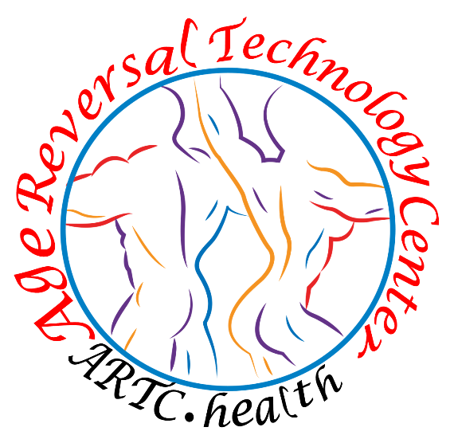
Our Contact information: Ph 941-806-5511
E- mail Address mmj.ARTC@gmail.com
Location Address 3226 Clark Rd.
Sarasota FL. 34231
Your Doctor Arthur Hodge, MD.

Your Patient Number: ________________________________________________
Florida Department of Health
OFFICE OF MEDICAL MARIJUANA
PH 800-808-9580

In the first 24 hrs. you need to check your e mail. You will have 2 e-mails from the Office of Medical Marijuana Fl Dept of Health. (Check YOUR Spam) These e-mails are so you can set up your patient site and finish the application process to receive your MMJ card from the State of Florida Health Dept / Office of Medical Marijuana Use. With access to your patient site, you can find out important information like: How much medicine you have available. when your O/A expires and more
First e-mail will have a link to the MMJ Patient Registry and your username for the website. (Your Username is your E mail address)
Second e-mail will have a temporary password. NOTE: This password expires in 24 hrs. So, if you wait to reply, you will have to get a new password from the OMMU. phone number above IMPORTANT Make sure you copy and paste the password, easy to do. No mistake this way! They only give you 3 tries and then you are locked out. You will then have to call the state to get unlocked.
Once you have set up your permanent password you will be on your patient site.
A tool bar will highlight with 3 options Click (Your Card) Your picture and all your information will be there. This is where you finish your application process for your Card. You only have three things to do.
- Follow the prompts. Choose state ID to supply your Photo. You will be asked to verify your information is correct. Then you will hit continue and apply to confirm your info Always choose State ID photo for your photo Do not upload one of your own. Choose state ID to verify proof of residency.

- You will next be asked to Digitally sign the application. All you have to do is type your name in two different boxes. Press ‘submit application’ if you did everything correctly, a a big check mark will appear and say Application/Submit Complete. If not. scroll up and see where you need help. If you have issues with the site, call the state.

- Once you have summited the Application you will be asked to pay the
$75 fee to the FL Dept of Health. This is easy they take Credit Cards / Debit Cards and Check on-line. Follow the directions.

You should get an e mail from the state again telling you they received your information. This process for your MMJ Card will take 24 hrs.
We encourage patients to check on their patient site after 48 hrs., if they have not received their approval e mail. This e mail can be printed out and serves as a Temporary Card until your permanent card comes in the mail.
Explore the options and information available to you on your page.
This is where you will have to renew your MMJ Card with the state program annually; Change your address; update information; find out when your O/A expires; How much THC, CBD and smokable flower you have on your O/A; Who your doctor is, etc.
At the end of 10 days you should have received your MMJ Card from the Office of Medical Marijuana via regular mail. As a reminder check your junk mail in your regular mail that might be your MMJ Card.

